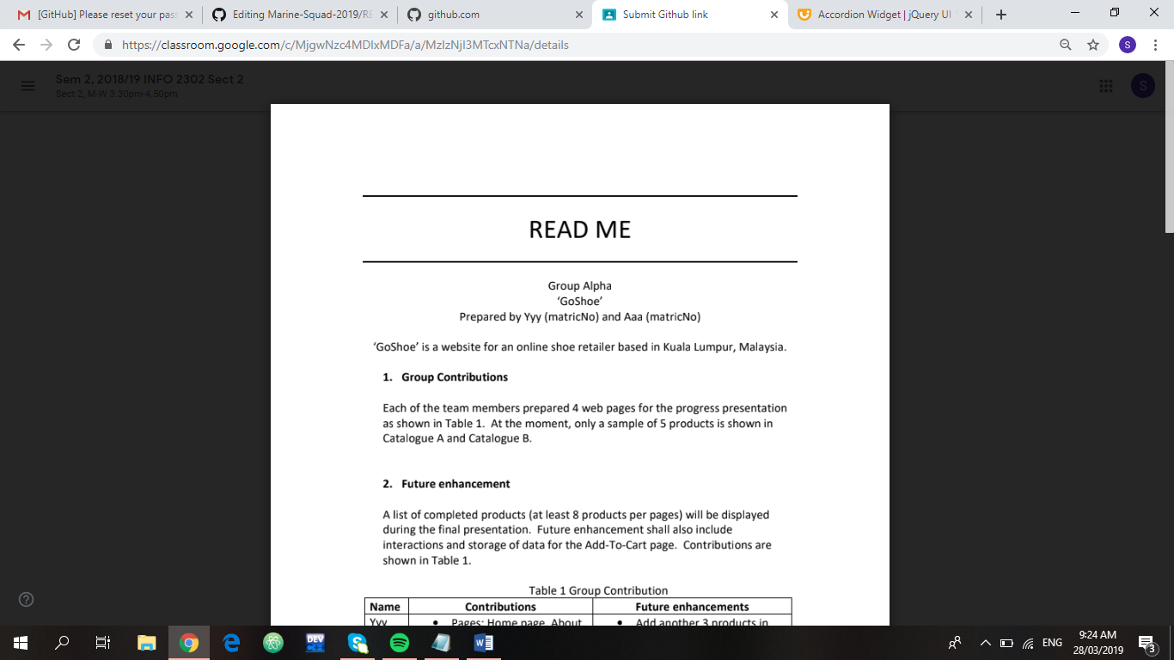

**Group Name: Marine Squad**

**Project Name: ‘Marine Defence’**

Prepared by Shazrina (1624336), Aisyah (1620632),

Syazaa (1711566), Zannat (1632738), Nadia (1714160)

‘Save our Marine Life’ is a website to encourage people to care about the ocean life more and also contributing their part towards the ecosystem as a citizen of the earth.

**1.** **Group Contributions**

**2.** **Future Enhancements**

|  |  |  |
| --- | --- | --- |
| **NAME** | **CONTRIBUTIONS** | **FUTURE ENHANCEMENTS** |
| Shazrina | * Pages: The team, Marine life facts, and Documentaries. * Web elements: iframe | * Will synchronize the layout with other pages. * Will use javascript for styling. * Will add more contents to facts. |
| Nur Aisyah | * Pages: News, Statistic, and Merchandise | * Will use more javascript for the news to make it more accessible. * Will add more icon on the statistic to make it interesting. * Will link up with real business in order to help us in achieving our objective. |
| Syazaa | * Pages: Home, FAQ, Contact us, Sign up, Donate/Pay it Foward, Login Membership page. * Overall design. | * Add donate/pay it forward and login membership page * Add more styling to home page * Fix codes which were not working |
| Zannat | * Pages: About, Mission, Vision, Collaboration | * Will use javascript, correct styling, add more contents and make it useful. |
| Nadia | * Pages: Programmes, Research and Join Us | * Will update more, will use JavaScript and add more content to make it useable. |

**3.** **Use of third-party resources**

Graphics: Team members Syazaa, Shazrina, and Aisyah obtained all graphics from Google.com.

|  |  |  |
| --- | --- | --- |
| **Web elements** | **Team members** | **Modifications** |
| Graphics for Home, the team, marine life facts, documentaries, news, statistics | Syazaa, Shazrina, Aisyah | All graphics are resized using CSS. |
| Home page icons taken from Awesome Icons  <https://fontawesome.com/icons> | Syazaa | * Added extra features i.e. hover feature |
|  |  |  |

**4.** **References**

* Kennedy, J. (2019, February 03). What You Need to Know About Marine Life. Retrieved March 14, 2019, from<https://www.thoughtco.com/marine-life-definition-and-examples-2291890>
* (n.d.). Retrieved March 14, 2019, from<https://developer.mozilla.org/en-US/docs/Web/CSS/color_value>
* Font. (n.d.). Retrieved March 14, 2019, from<https://developer.mozilla.org/en-US/docs/Web/CSS/font>
* Turtle Icon. Retrieved March 14, 2019, from<http://icons.iconarchive.com/icons/martin-berube/flat-animal/256/turtle-icon.png>
* Marine Life. (n.d.). Retrieved March 13, 2019, from <https://www.independent.co.uk/topic/marine-life>
* (n.d.). Retrieved March 14, 2019, from <http://www.unesco.org/new/en/natural-sciences/ioc-oceans/focus-areas/rio-20-ocean/blueprint-for-the-future-we-want/marine-biodiversity/facts-and-figures-on-marine-biodiversity/>
* MarineBio Projects. (n.d.). Retrieved March 13, 2019, from <https://marinebio.org/marinebio/projects/>
* US Department of Commerce, & National Oceanic and Atmospheric Administration. (2010, May 22). WaterLife: Sea Turtles and the Quest to Nest. Retrieved March 13, 2019, from <https://games.noaa.gov/seaturtle/digitalprojects.html>
* US Department of Commerce, & National Oceanic and Atmospheric Administration. (2018, June 05). NOAA's National Ocean Service. Retrieved March 13, 2019, from <https://oceanservice.noaa.gov/>
* Save Our Marine Life. (2018, December 12). Retrieved March 13, 2019, from <https://en.m.wikipedia.org/wiki/Save_Our_Marine_Life>
* 10 Amazing Organizations Fighting to Save Our Oceans. (2018, March 14). Retrieved March 13, 2019, from <https://dipndive.com/blog/10-amazing-organizations-fighting-to-save-our-oceans.html>
* 5 Incredible Ocean Activists Who Have Changed The World. (2018, March 19). Retrieved March 13, 2019, from <https://thegreenhubonline.com/2018/03/19/5-incredible-ocean-activists-who-have-changed-the-world/>
* Power, A. M., Merder, J., Browne, P., Freund, J. A., Fullbrook, L., Graham, C., . . . Johnson, M. P. (2019, March 26). Field-recorded data on habitat, density, growth and movement of Nephrops norvegicus. Retrieved March 13, 2019, from <https://www.nature.com/articles/s41597-019-0013-x>
* Marine Biology News. (n.d.). Retrieved March 13, 2019, from <https://www.sciencedaily.com/news/plants_animals/marine_biology/>